**CRITERIA C: DEVELOPMENT**

**TECHNICAL SUMMARY**

Free technologies have been used considering costs which also suit the needs of the client running a non-profit organization.

|  |  |
| --- | --- |
| **Technology** | **Details** |
| Database | Autonomous Database instance on Oracle Cloud (Free Tier Account). Oracle database is a relational database management system. |
| Query Language | SQL (Structured Query Language) for creating database tables and data inserts/updates. |
| Programming Language | Python programming language (open source and high-level programming language) |
| Web Framework | Flask micro web framework for web application (Free, open source) |
| Markup Language | HTML (Hyper Text Markup Language) for web pages |
| Style Sheet Language | CSS (Cascading Style Sheets) for styling in HTML |

**DATABASE TABLES & DATA**

The physical database tables in the Oracle database required for the application were created using the ERDs (Entity Relationship Diagrams) and data model diagrams from the design stage.

Free-Tier Oracle Cloud Account was first created, and an autonomous database instance started as below.

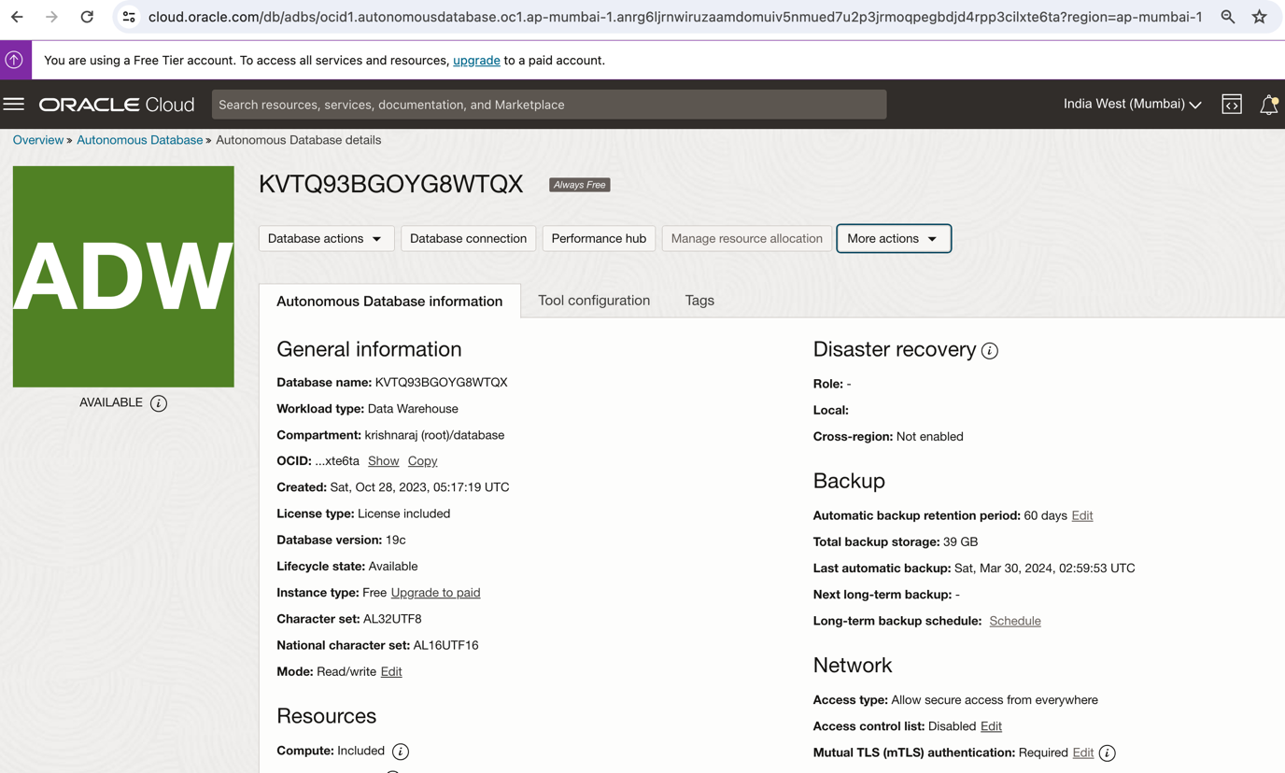

Using SQL session, the database tables were created using DDL (data definition language) create table statements.

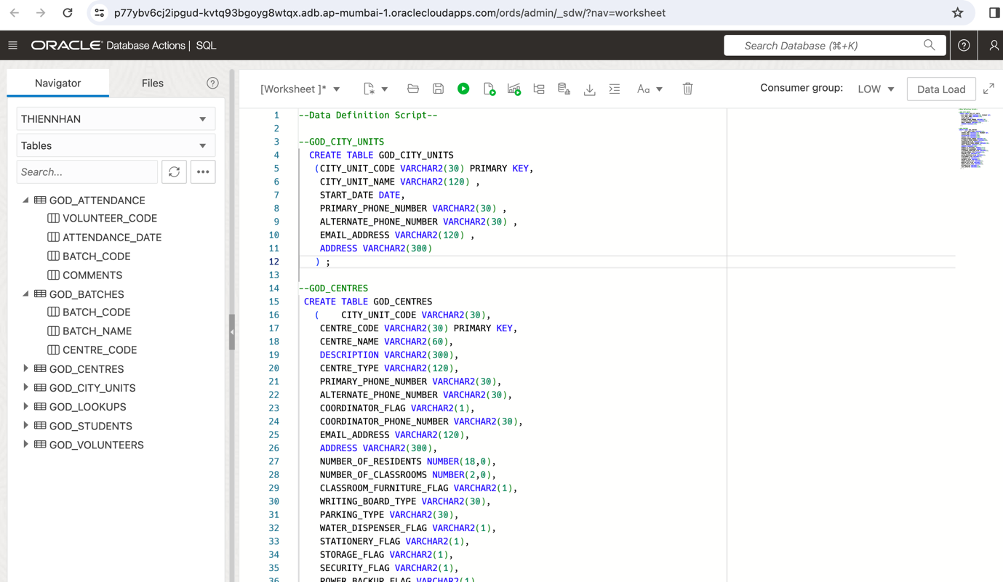

Sample data for development and testing were then inserted using DML (data manipulation language) insert statements.

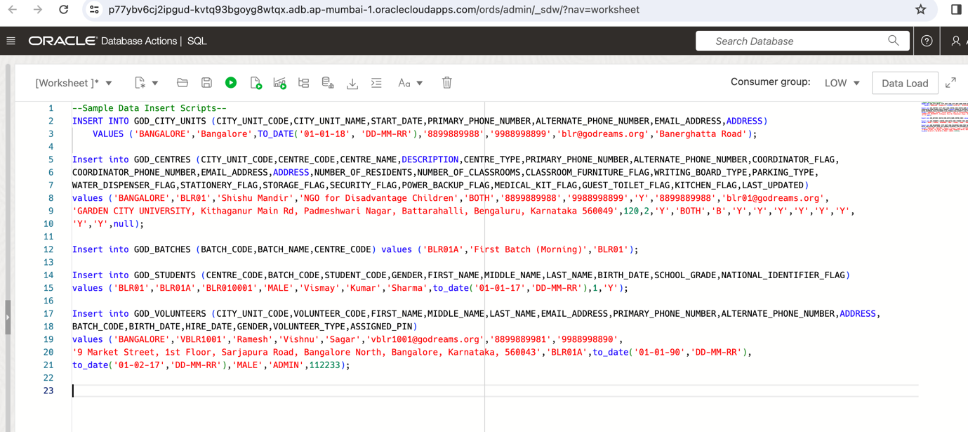

Actual client data will be inserted by client after software handover through editing the sample scripts provided. The complete script is provided in Appendix 2.

**SQL QUERIES FOR VALIDATION & PAGE INFORMATION**

The SQL queries needed for fetching information in each of the application pages and used for validation (Example: username/password check) were coded.

Login Validation:

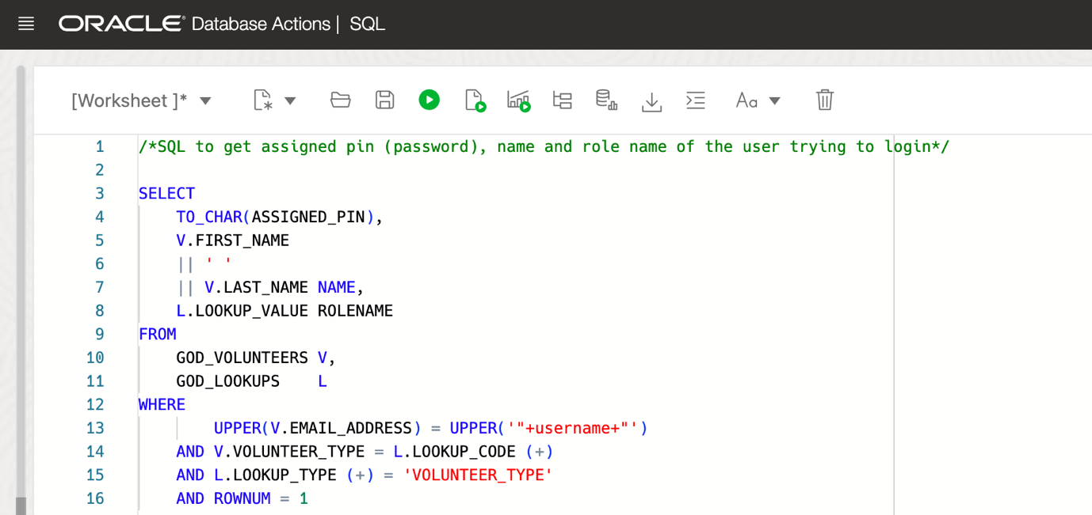

Childcare Institutions List:

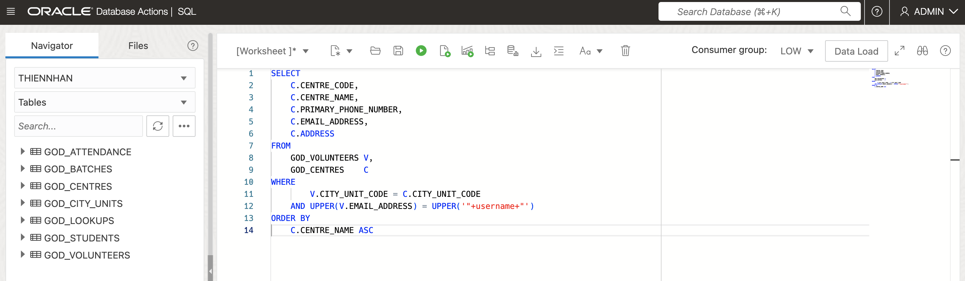

Appendix 2 has all the SQLs used.